CALCULATION PROBLEMS
Pearson Edexcel – Monday 8 June 2020 - Paper 3 (Calculator) Higher Tier
1.
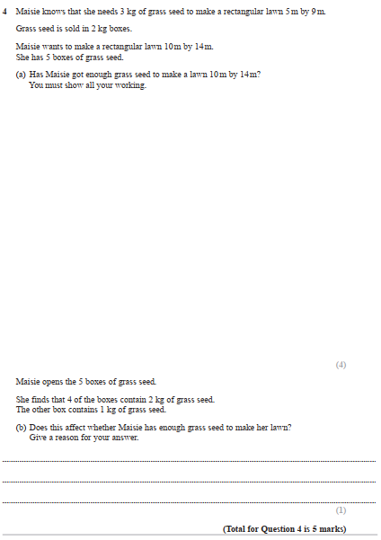

Pearson Edexcel - Tuesday 21 May 2019 - Paper 1 (Non-Calculator) Higher Tier
2.
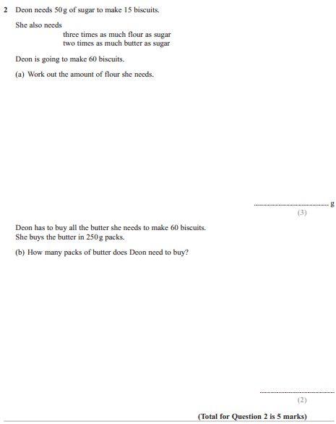

Pearson Edexcel - Thursday 6 June 2019 - Paper 2 (Calculator) Higher Tier
3.
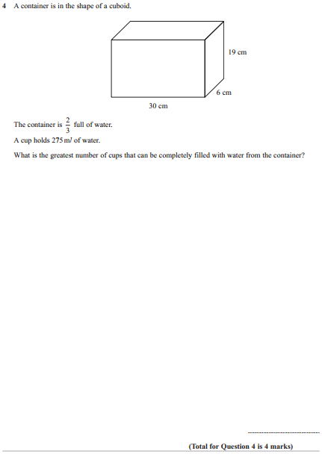

Pearson Edexcel - Thursday 8 November 2018 - Paper 2 (Calculator) Higher Tier
4.
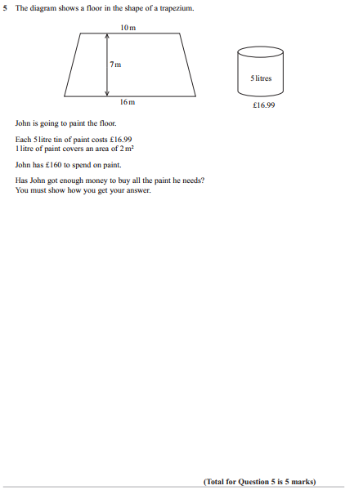

Pearson Edexcel - Monday 12 November 2018 - Paper 3 (Calculator) Higher Tier
5.
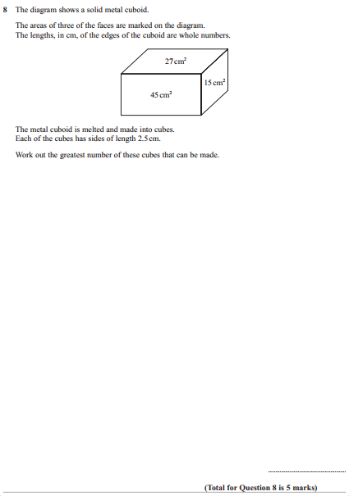

Pearson Edexcel - Tuesday 12 June 2018 - Paper 3 (Calculator) Higher Tier
6.
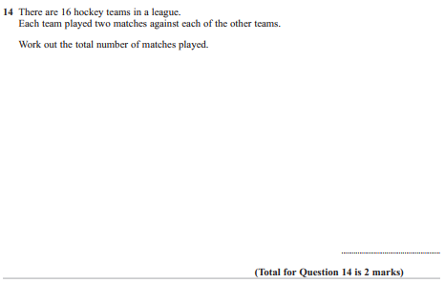
Pearson Edexcel - Thursday 2 November 2017 - Paper 1 (Non-Calculator) Higher Tier
7.
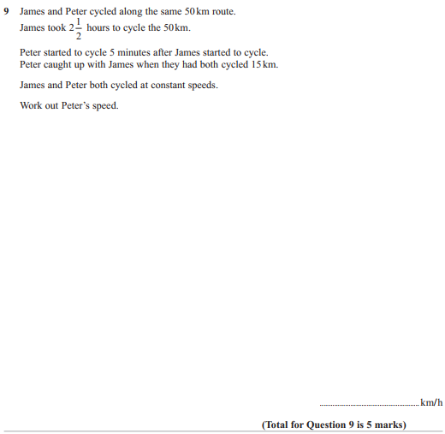
Pearson Edexcel - Thursday 2 November 2017 - Paper 1 (Non-Calculator) Higher Tier
8.
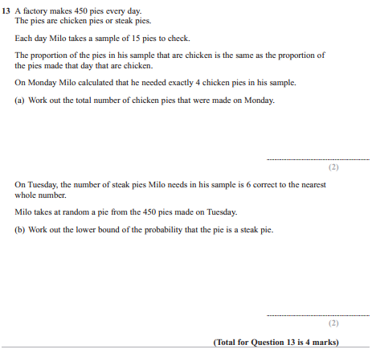

Pearson Edexcel - Thursday 2 November 2017 - Paper 1 (Non-Calculator) Higher Tier
9.
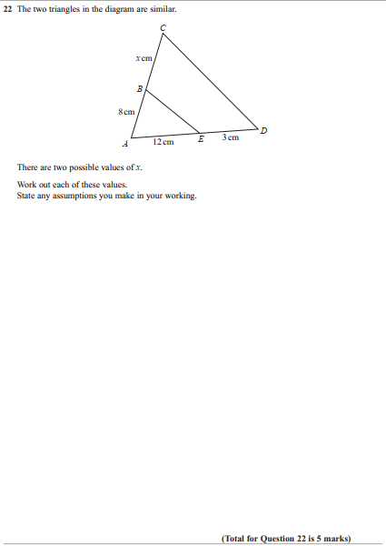
Pearson Edexcel - Thursday 2 November 2017 - Paper 1 (Non-Calculator) Higher Tier
10.
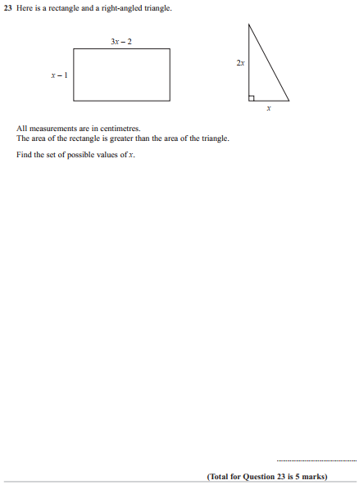

Pearson Edexcel - Monday 6 November 2017 - Paper 2 (Calculator) Higher Tier
11.
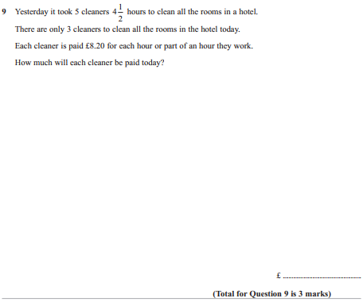
Pearson Edexcel - Monday 6 November 2017 - Paper 2 (Calculator) Higher Tier
12.
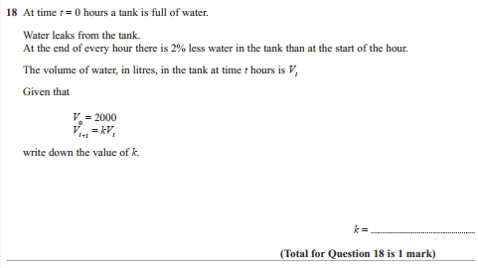

Pearson Edexcel - Wednesday 8 November 2017 - Paper 3 (Calculator) Higher Tier
13.
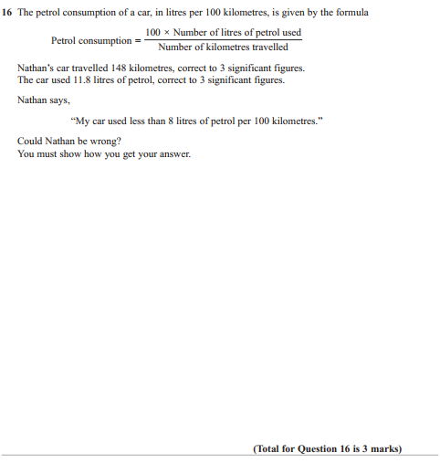

Pearson Edexcel - Thursday 25 May 2017 - Paper 1 (Non-Calculator) Higher Tier
14.
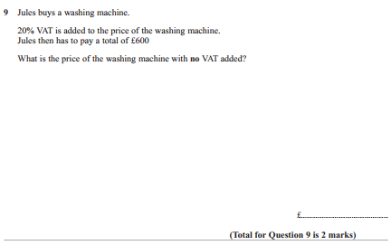
Pearson Edexcel - Thursday 25 May 2017 - Paper 1 (Non-Calculator) Higher Tier
15.
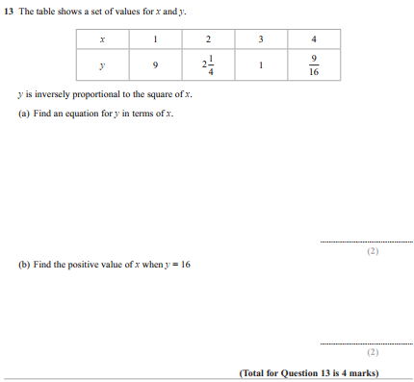
Pearson Edexcel - Thursday 8 June 2017 - Paper 2 (Calculator) Higher Tier
16.
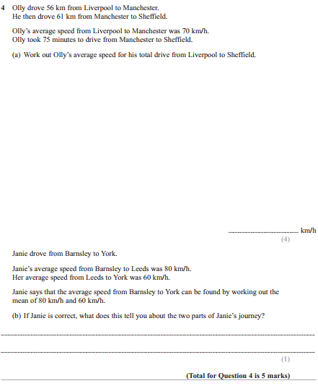

Pearson Edexcel - Thursday 8 June 2017 - Paper 2 (Calculator) Higher Tier
17.
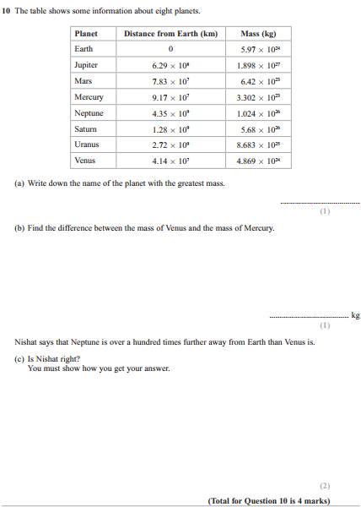

Pearson Edexcel - Tuesday 13 June 2017 - Paper 3 (Calculator) Higher Tier
18.
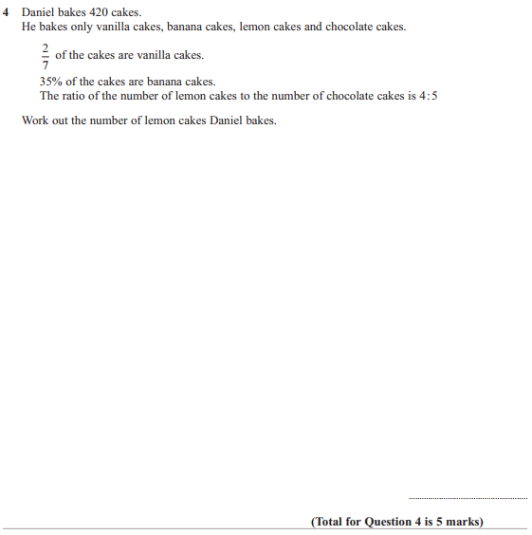

Pearson Edexcel - Specimen Papers Set 2 - Paper 1 (Non-Calculator) Higher Tier
19.
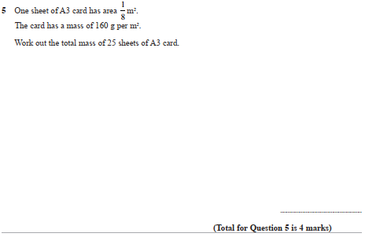
Pearson Edexcel - Specimen Papers Set 2 - Paper 1 (Non-Calculator) Higher Tier
20.
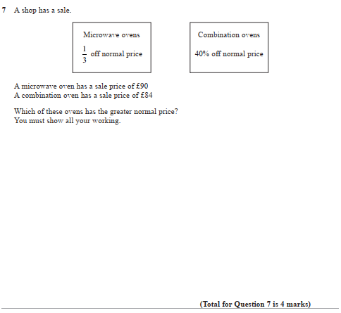
Pearson Edexcel - Specimen Papers Set 2 - Paper 3 (Calculator) Higher Tier
21.
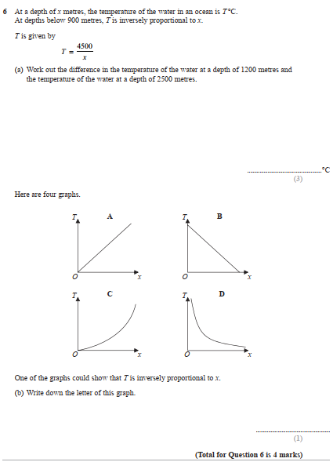

Pearson Edexcel - Specimen Papers Set 1 - Paper 1 (Non-Calculator) Higher Tier
22.
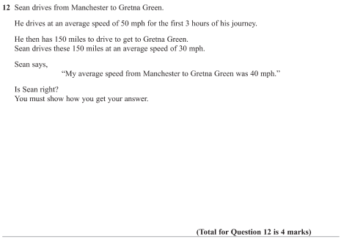
Pearson Edexcel - Specimen Papers Set 1 - Paper 2 (Calculator) Higher Tier
23.
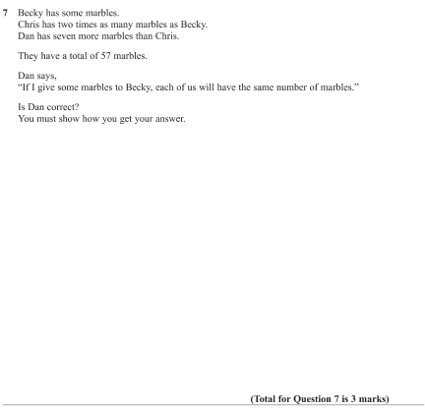
Pearson Edexcel - Specimen Papers Set 1 - Paper 2 (Calculator) Higher Tier
24.
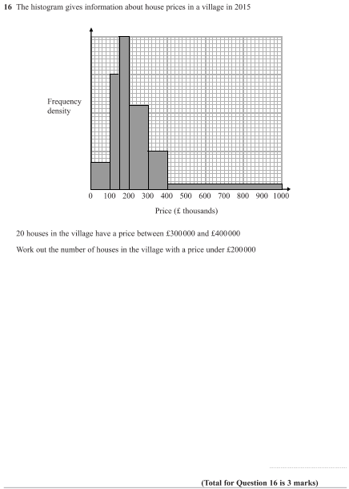
Pearson Edexcel - Specimen Papers Set 1 - Paper 2 (Calculator) Higher Tier
25.
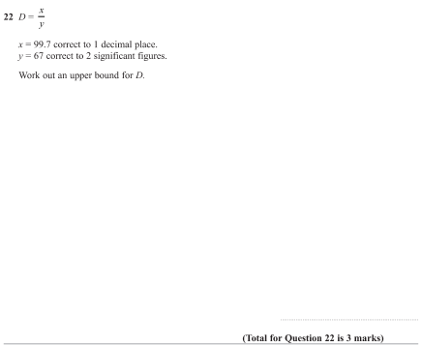

Pearson Edexcel - Specimen Papers Set 1 - Paper 3 (Calculator) Higher Tier
26.
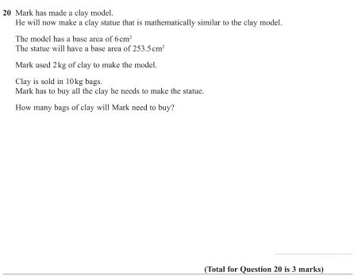

Pearson Edexcel - Sample Paper 1 - (Non-Calculator) Higher Tier
27.
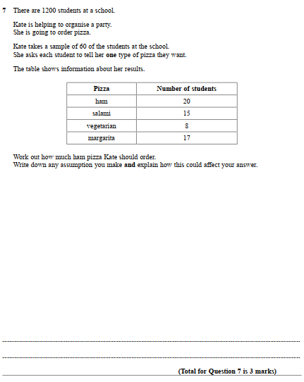

Pearson Edexcel - Sample Paper 2 - (Calculator) Higher Tier
28.

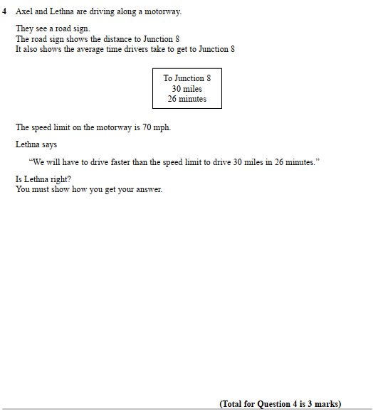

Pearson Edexcel - Sample Paper 3 - (Calculator) Higher Tier
29.
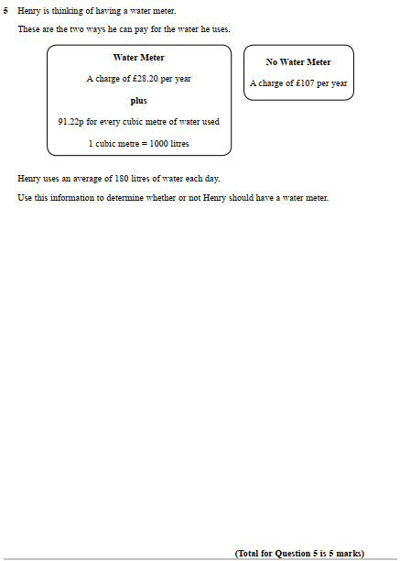

Pearson Edexcel - Thursday 26 May 2016 - Paper 1 (Non-Calculator) Higher Tier
30.
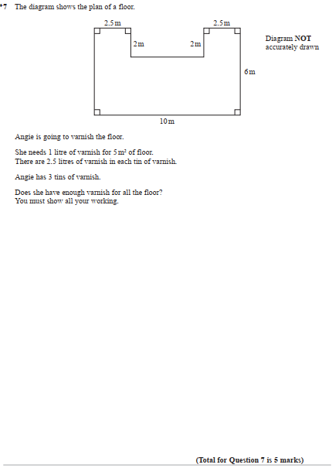

Pearson Edexcel - Thursday 9 June 2016 - Paper 2 (Calculator) Higher Tier
31.
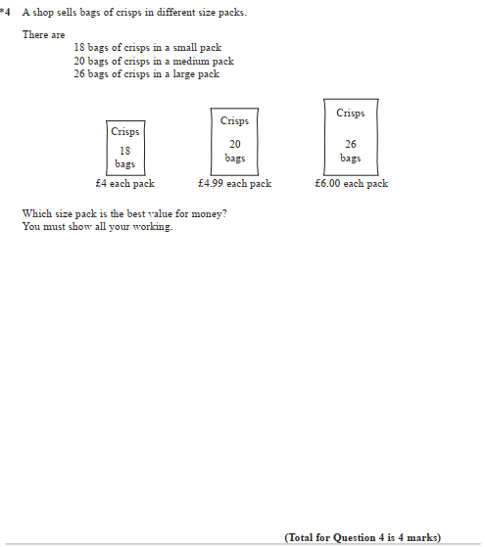

Pearson Edexcel - Thursday 9 June 2016 - Paper 2 (Calculator) Higher Tier
32.
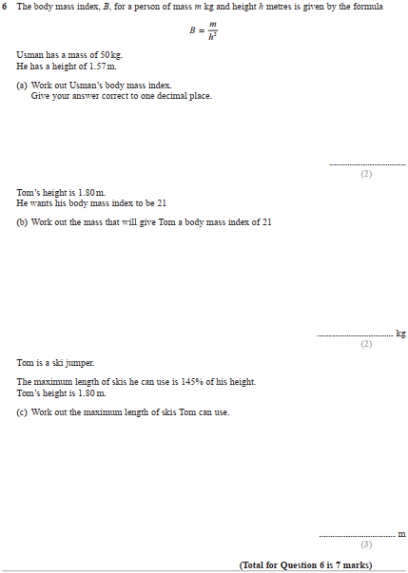

Pearson Edexcel - Thursday 9 June 2016 - Paper 2 (Calculator) Higher Tier
33.
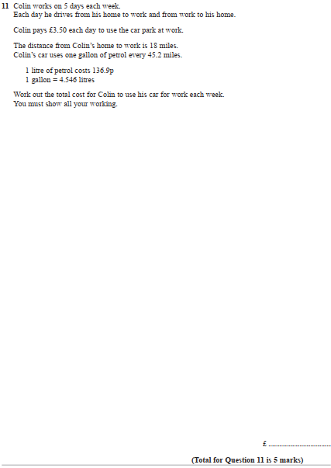

Pearson Edexcel - Wednesday 4 November 2015 - Paper 1 (Non-Calculator) Higher Tier
34.
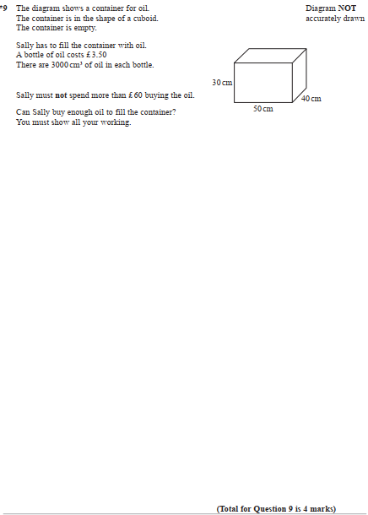

Pearson Edexcel - Friday 6 November 2015 - Paper 2 (Calculator) Higher Tier
35.
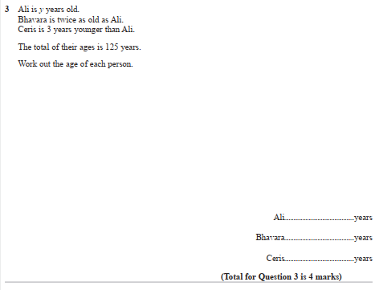

Pearson Edexcel - Thursday 4 June 2015 - Paper 1 (Non-Calculator) Higher Tier
36.
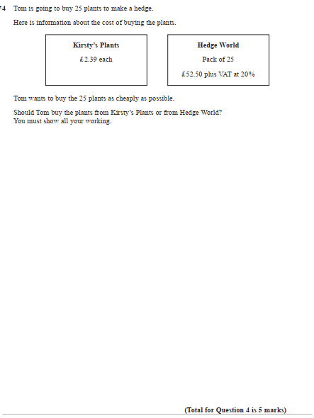

Pearson Edexcel - Monday 8 June 2015 - Paper 2 (Calculator) Higher Tier
37.
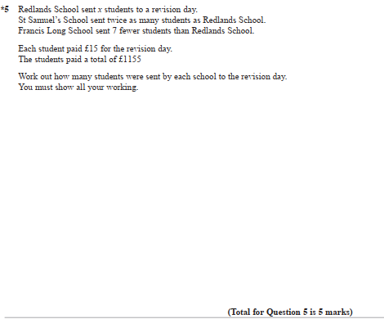
Pearson Edexcel - Monday 8 June 2015 - Paper 2 (Calculator) Higher Tier
38.
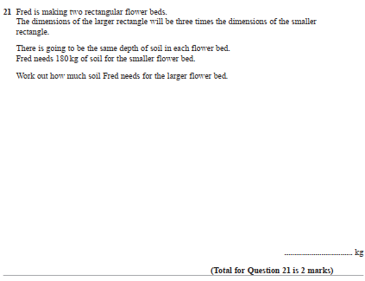
Pearson Edexcel - Monday 8 June 2015 - Paper 2 (Calculator) Higher Tier
39.
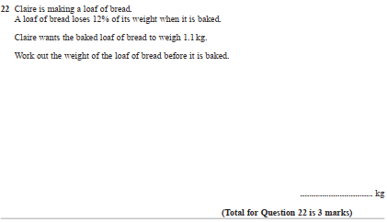
Pearson Edexcel - Wednesday 5 November 2014 - Paper 1 (Non-Calculator) Higher Tier
40.
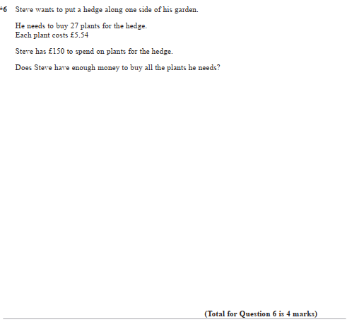
Pearson Edexcel - Wednesday 5 November 2014 - Paper 1 (Non-Calculator) Higher Tier
41.
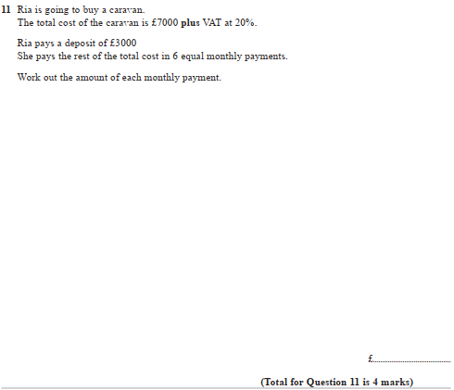

Pearson Edexcel - Wednesday 5 November 2014 - Paper 1 (Non-Calculator) Higher Tier
42.
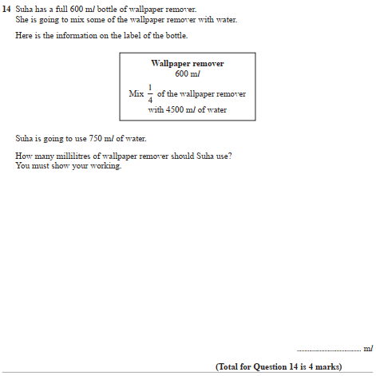

Pearson Edexcel - Friday 7 November 2014 - Paper 2 (Calculator) Higher Tier
43.
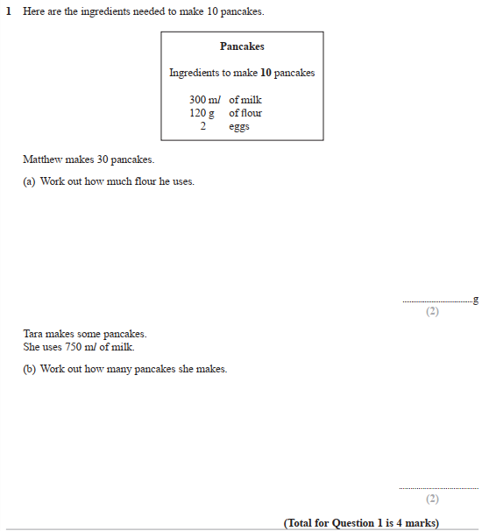

Pearson Edexcel - Friday 7 November 2014 - Paper 2 (Calculator) Higher Tier
44.
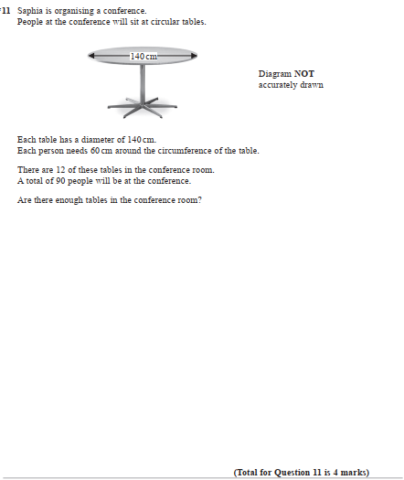

Pearson Edexcel - Monday 9 June 2014 - Paper 1 (Non-Calculator) Higher Tier
45.
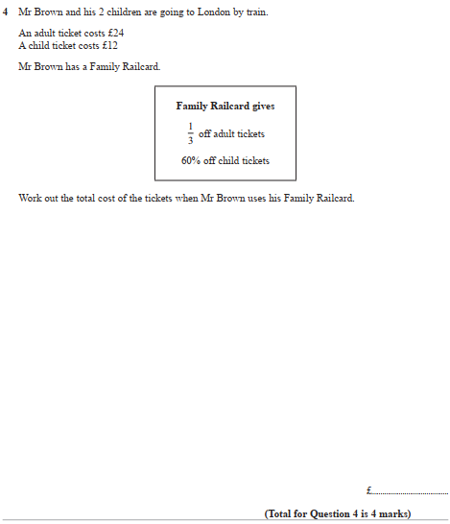

Pearson Edexcel - Friday 13 June 2014 - Paper 2 (Calculator) Higher Tier
46.
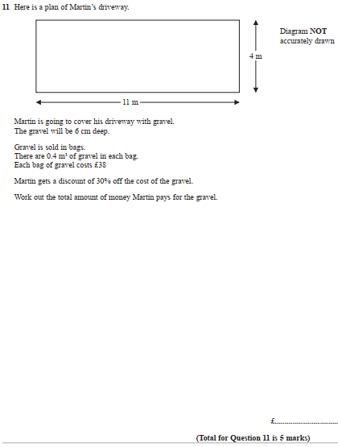

Pearson Edexcel - Wednesday 6 November 2013 - Paper 1 (Non-Calculator) Higher Tier
47.
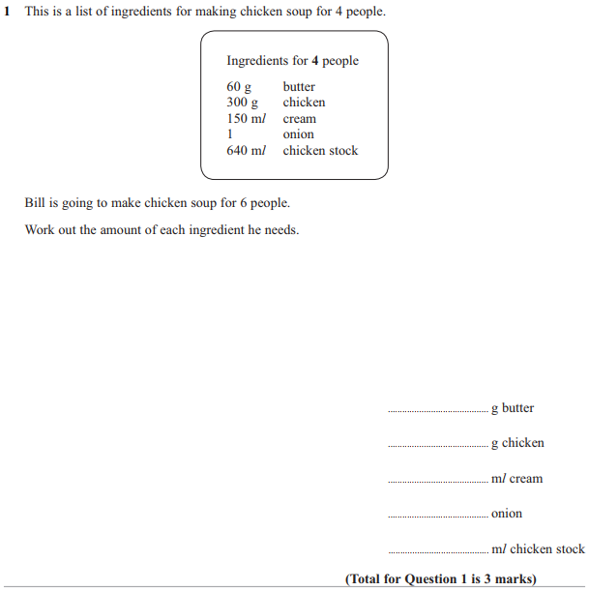

Pearson Edexcel - Wednesday 6 November 2013 - Paper 1 (Non-Calculator) Higher Tier
48.
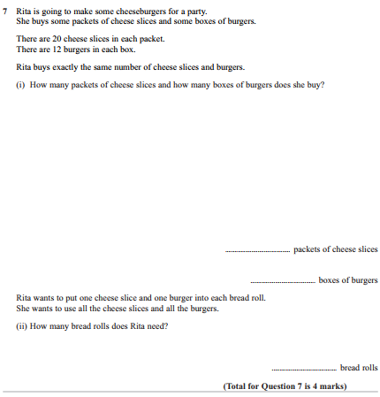

Pearson Edexcel - Friday 8 November 2013 - Paper 2 (Calculator) Higher Tier
49.
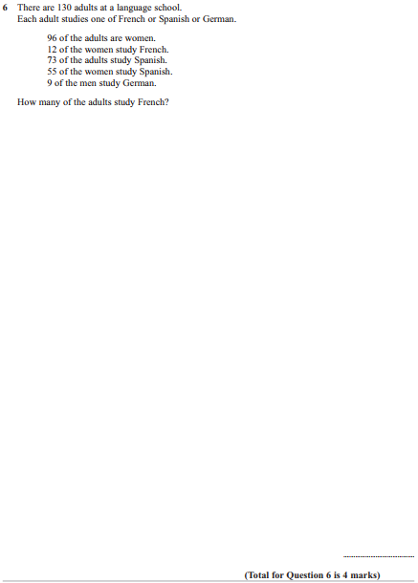

Pearson Edexcel - Friday 8 November 2013 - Paper 2 (Calculator) Higher Tier
50.
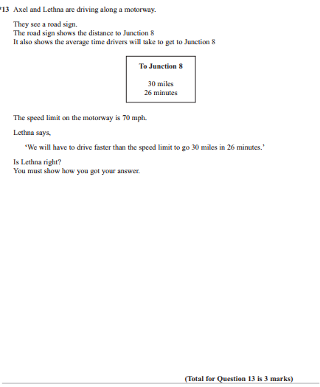

Pearson Edexcel - Friday 8 November 2013 - Paper 2 (Calculator) Higher Tier
51.
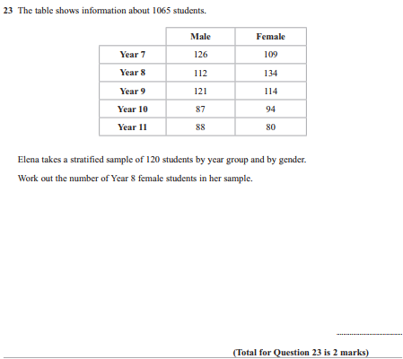

Pearson Edexcel - Tuesday 11 June 2013 - Paper 1 (Non-Calculator) Higher Tier
52.
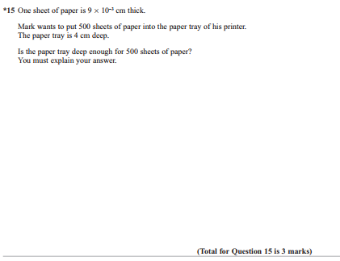
Pearson Edexcel - Friday 14 June 2013 - Paper 2 (Calculator) Higher Tier
53.
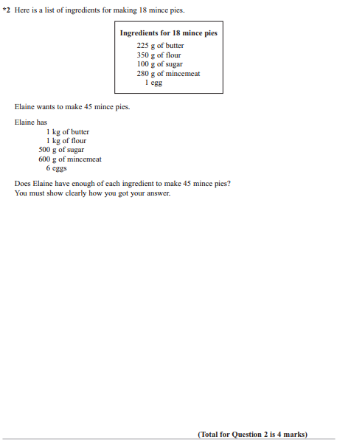

Pearson Edexcel - Friday 14 June 2013 - Paper 2 (Calculator) Higher Tier
54.
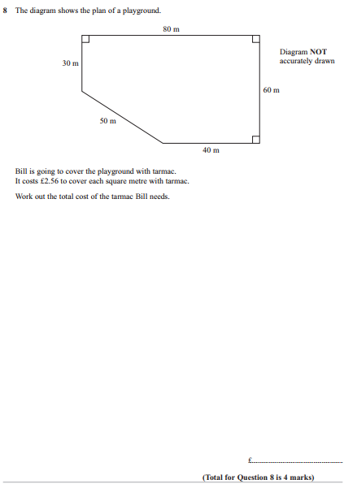

Pearson Edexcel - Friday 14 June 2013 - Paper 2 (Calculator) Higher Tier
55.
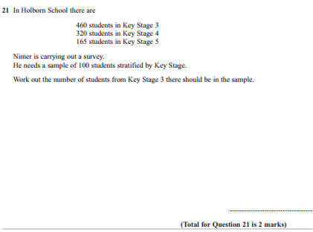

Pearson Edexcel - Monday 4 March 2013 - Paper 2 (Calculator) Higher Tier
56.
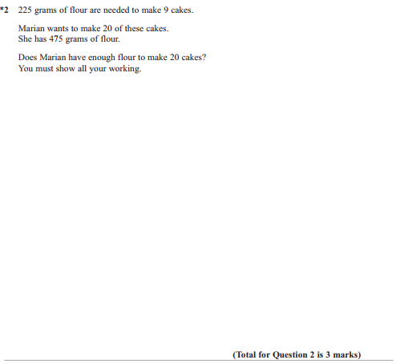
Pearson Edexcel - Monday 4 March 2013 - Paper 2 (Calculator) Higher Tier
57.
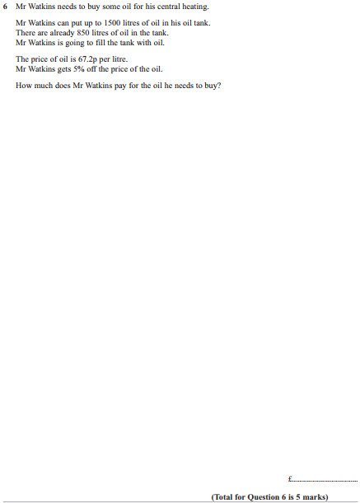

Pearson Edexcel - Monday 4 March 2013 - Paper 2 (Calculator) Higher Tier
58.
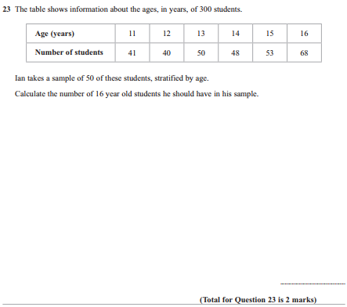

Pearson Edexcel - Tuesday 6 November 2012 - Paper 1 (Non-Calculator) Higher Tier
59.
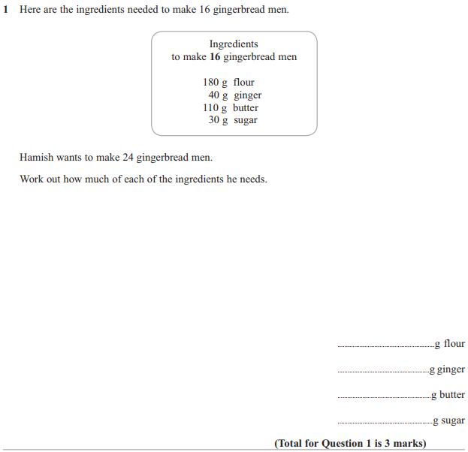

Pearson Edexcel - Tuesday 6 November 2012 - Paper 1 (Non-Calculator) Higher Tier
60.
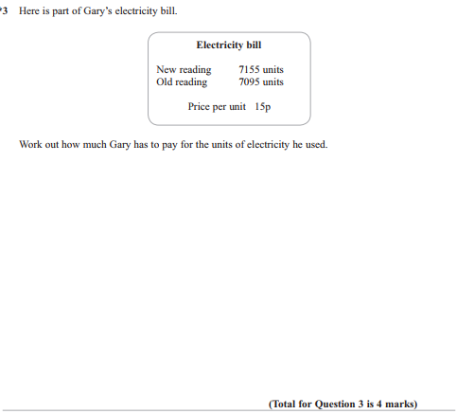

Pearson Edexcel - Tuesday 6 November 2012 - Paper 1 (Non-Calculator) Higher Tier
61.
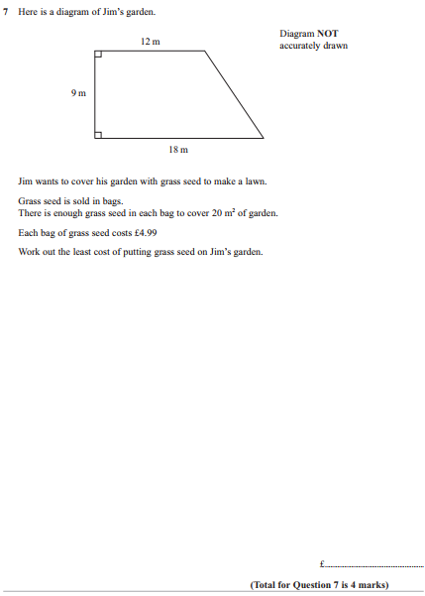

Pearson Edexcel - Tuesday 6 November 2012 - Paper 1 (Non-Calculator) Higher Tier
62.
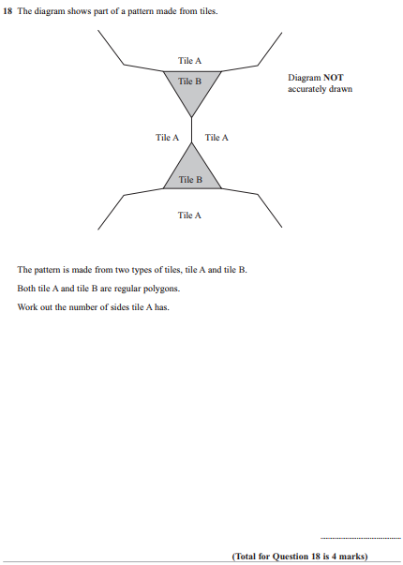

Pearson Edexcel - Thursday 8 November 2012 - Paper 2 (Calculator) Higher Tier
63.
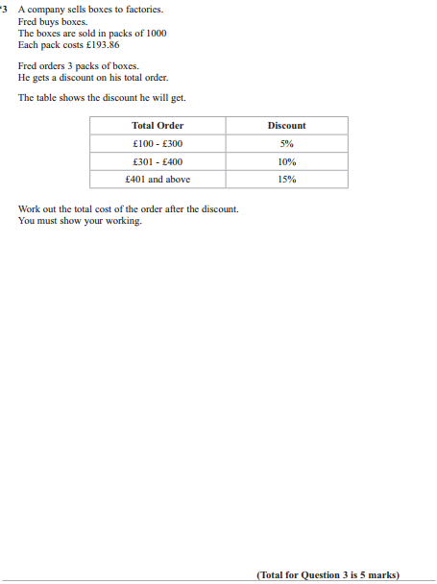
Pearson Edexcel - Thursday 8 November 2012 - Paper 2 (Calculator) Higher Tier
64.
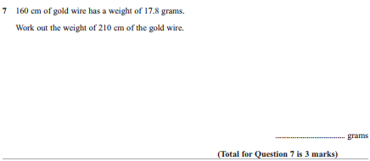
Pearson Edexcel - Monday 11 June 2012 - Paper 1 (Non-Calculator) Higher Tier
65.
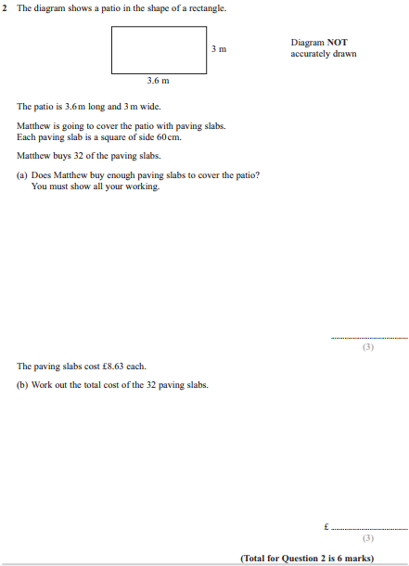

Pearson Edexcel - Monday 11 June 2012 - Paper 1 (Non-Calculator) Higher Tier
66.
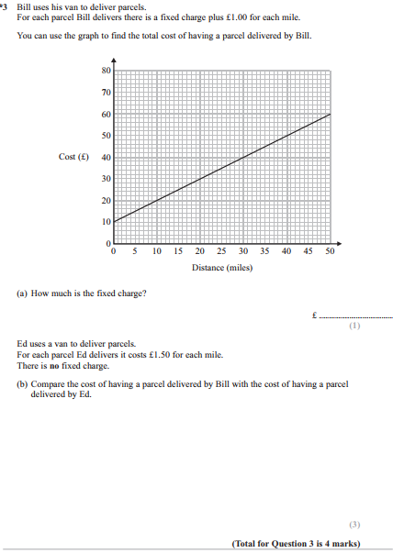

Pearson Edexcel - Monday 11 June 2012 - Paper 1 (Non-Calculator) Higher Tier
67.
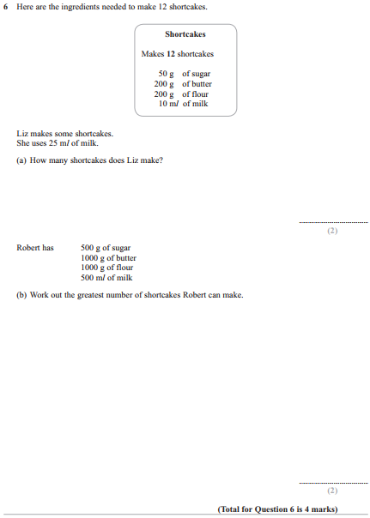

Pearson Edexcel - Monday 11 June 2012 - Paper 1 (Non-Calculator) Higher Tier
68.
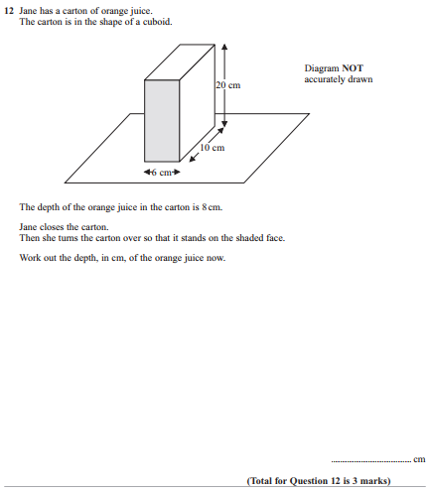

Pearson Edexcel - Wednesday 13 June 2012 - Paper 2 (Calculator) Higher Tier
69.
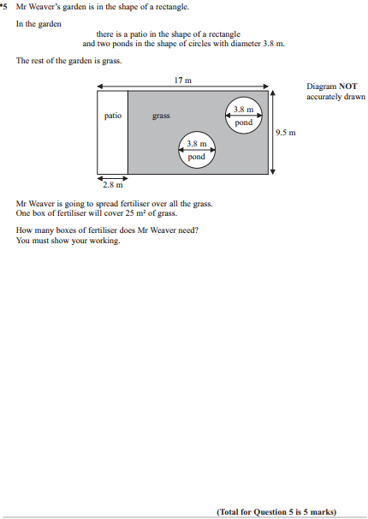

Pearson Edexcel - Wednesday 13 June 2012 - Paper 2 (Calculator) Higher Tier
70.
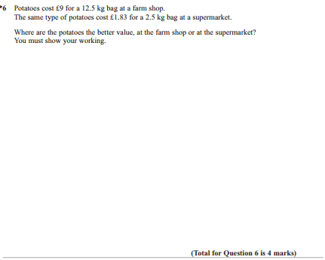

Pearson Edexcel - Wednesday 13 June 2012 - Paper 2 (Calculator) Higher Tier
71.
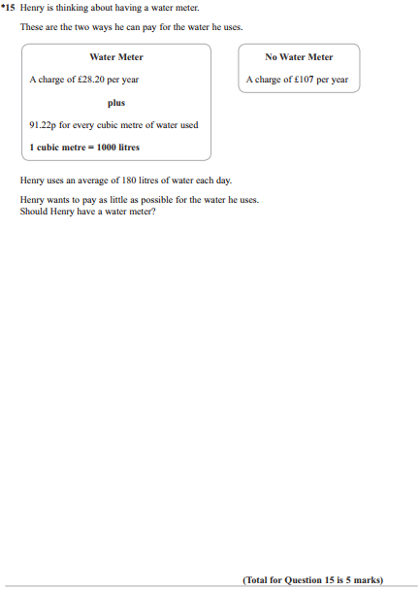

Pearson Edexcel - Wednesday 13 June 2012 - Paper 2 (Calculator) Higher Tier
72.
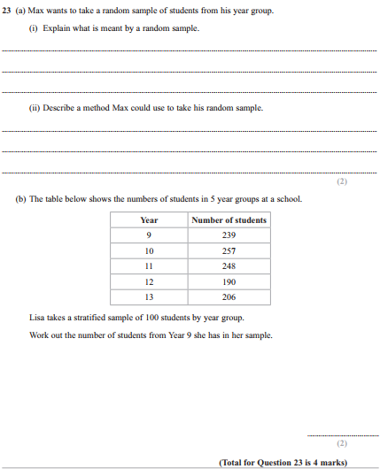

Pearson Edexcel - Friday 2 March 2012 - Paper 3 (Non-Calculator) Higher Tier
73.
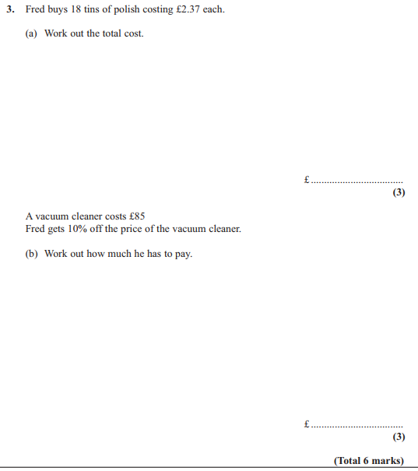

Pearson Edexcel - Monday 5 March 2012 - Paper 4 (Calculator) Higher Tier
74.
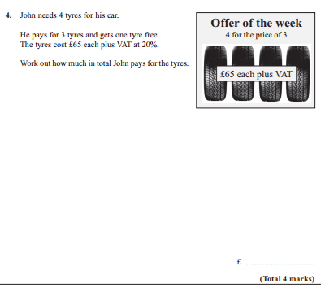

Pearson Edexcel - Monday 6 June 2011 - Paper 3 (Non-Calculator) Higher Tier
75.
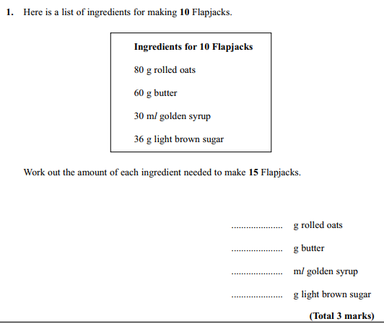

Pearson Edexcel - Monday 6 June 2011 - Paper 3 (Non-Calculator) Higher Tier
76.
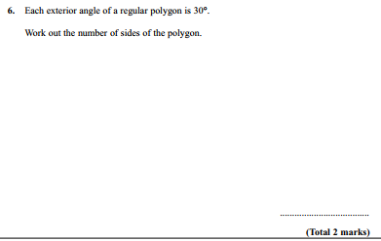

Pearson Edexcel - Friday 10 June 2011 - Paper 4 (Calculator) Higher Tier
77.
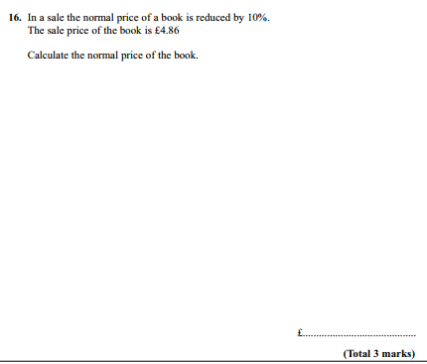

Pearson Edexcel - Friday 10 June 2011 - Paper 4 (Calculator) Higher Tier
78.

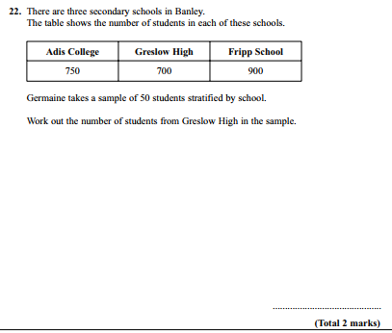

Pearson Edexcel - Tuesday 9 November 2010 - Paper 3 (Non-Calculator) Higher Tier
79.
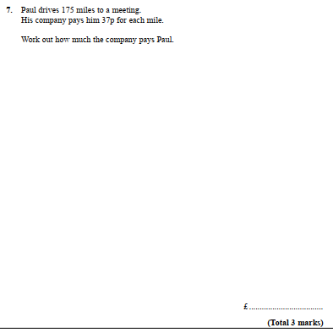
Pearson Edexcel - Tuesday 9 November 2010 - Paper 3 (Non-Calculator) Higher Tier
80.
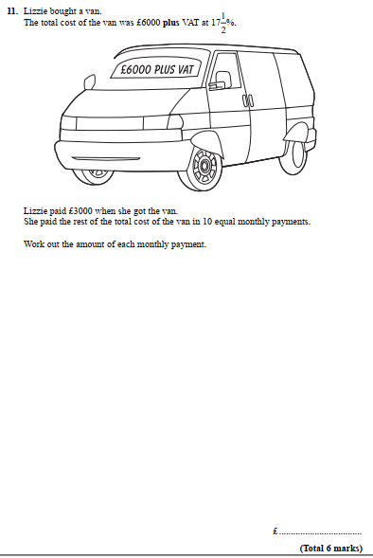

Pearson Edexcel - Tuesday 9 November 2010 - Paper 3 (Non-Calculator) Higher Tier
81.
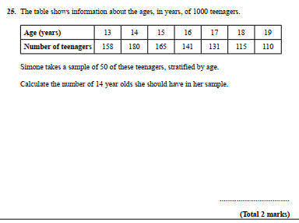
Pearson Edexcel - Friday 12 November 2010 - Paper 4 (Calculator) Higher Tier
82.
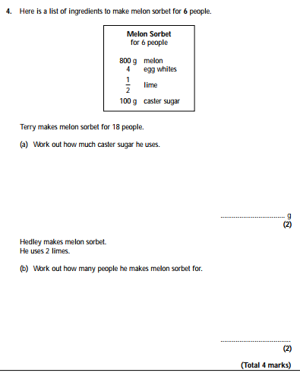
Pearson Edexcel - Friday 12 November 2010 - Paper 4 (Calculator) Higher Tier
83.
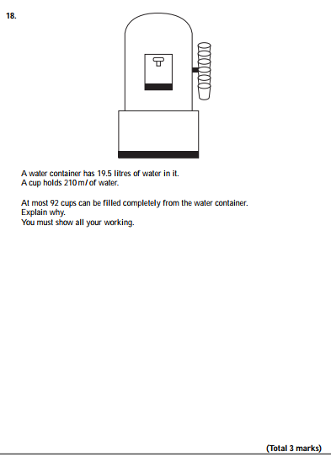

Pearson Edexcel - Friday 11 June 2010 - Paper 4 (Calculator) Higher Tier
84.
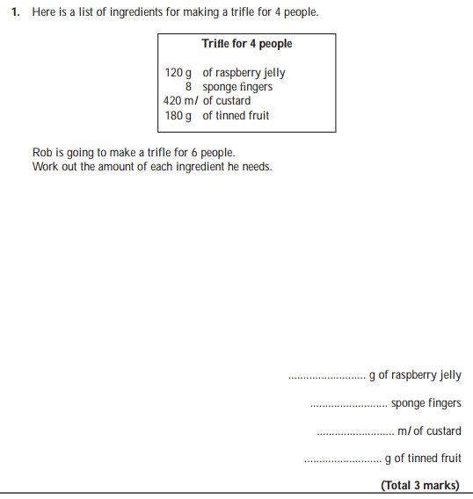

Pearson Edexcel - Tuesday 10 November 2009 - Paper 4 (Calculator) Higher Tier
85.
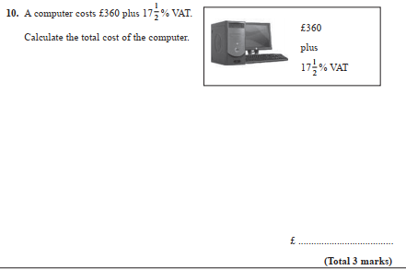

Pearson Edexcel - Tuesday 10 November 2009 - Paper 4 (Calculator) Higher Tier
86.
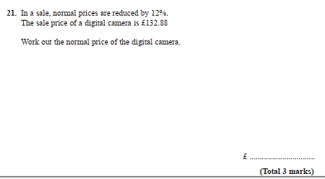

Pearson Edexcel - Tuesday 10 November 2009 - Paper 4 (Calculator) Higher Tier
87.
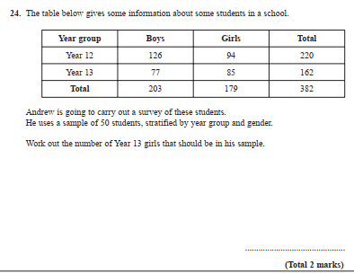

OCR GSCE – Tuesday 3 November 2020 – Paper 4 (Calculator) Higher Tier
88.
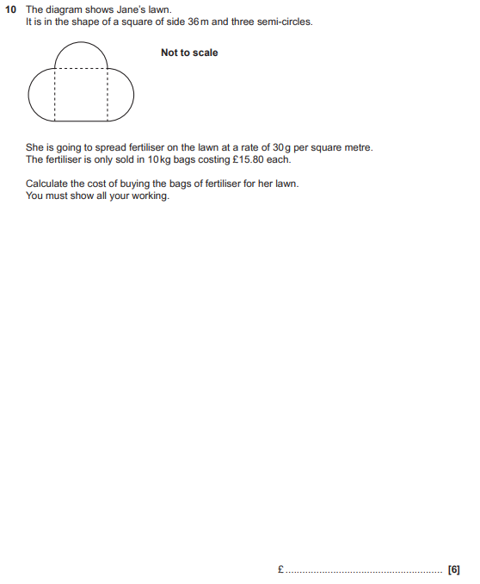

OCR GSCE – Monday 9 November 2020 – Paper 6 (Calculator) Higher Tier
89.
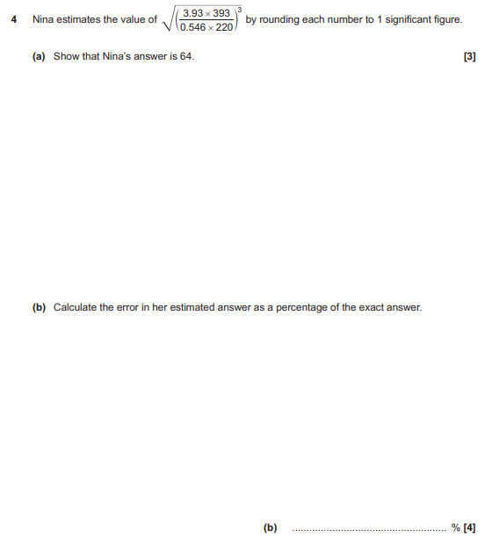

OCR GSCE – Monday 11 November 2019 – Paper 6 (Calculator) Higher Tier
90.
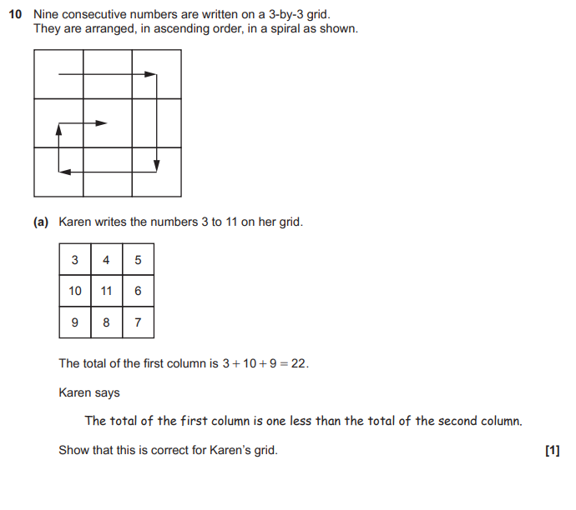
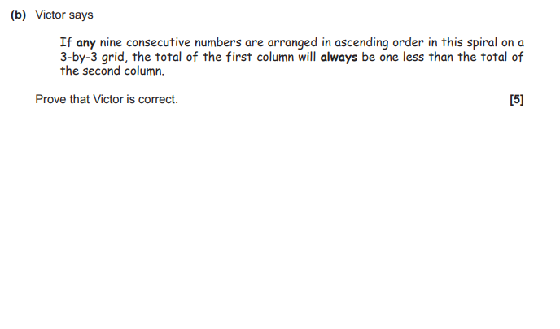

OCR GSCE – Thursday 6 June 2019 – Paper 5 (Non-Calculator) Higher Tier
91.
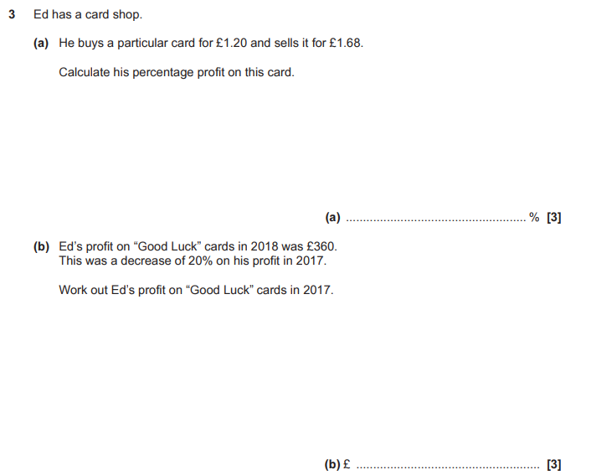

OCR GSCE – Tuesday 11 June 2019 – Paper 6 (Calculator) Higher Tier
92.
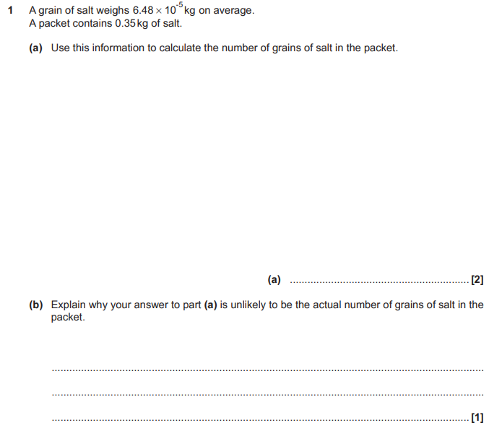

OCR GSCE – Tuesday 11 June 2019 – Paper 6 (Calculator) Higher Tier
93.
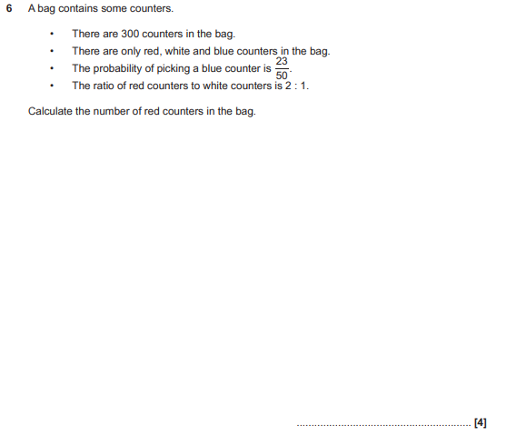

OCR GSCE – Thursday 8 November 2018 – Paper 5 (Non-Calculator) Higher Tier
94.
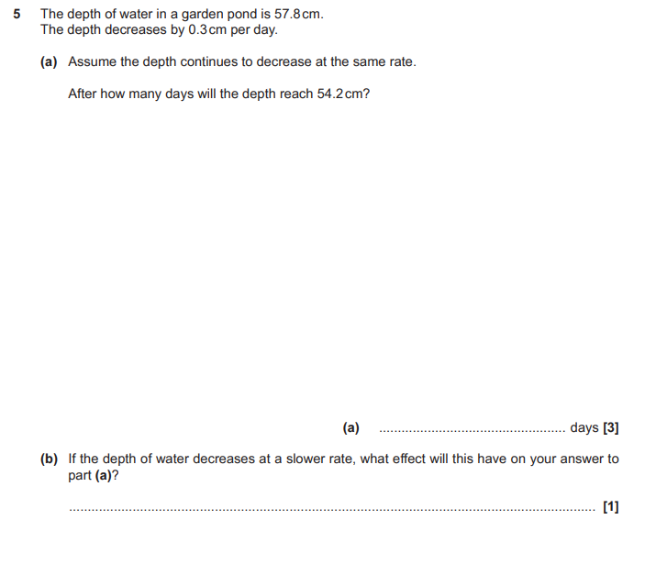

OCR GSCE – Monday 12 November 2018 – Paper 6 (Calculator) Higher Tier
95.
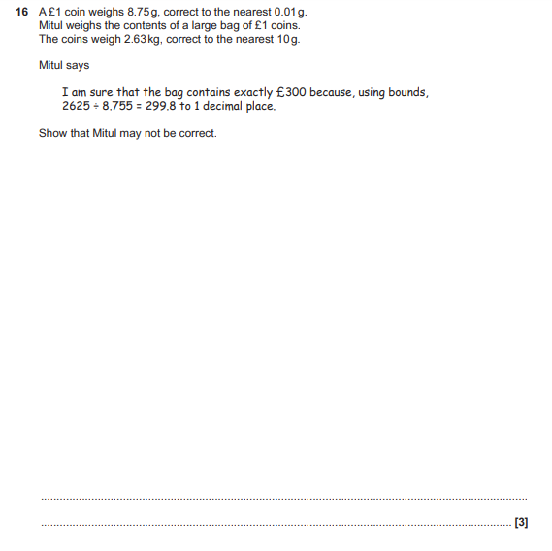

OCR GSCE – Tuesday 12 June 2018 – Paper 6 (Calculator) Higher Tier
96.
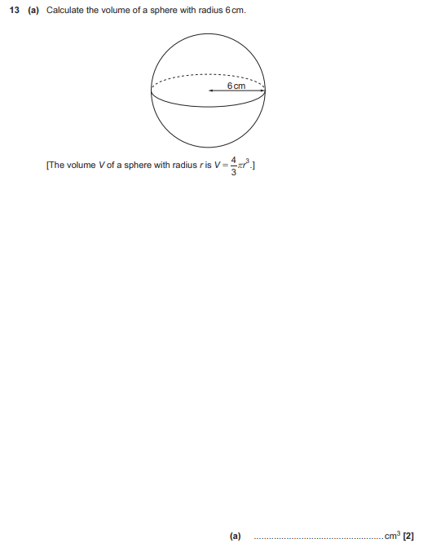
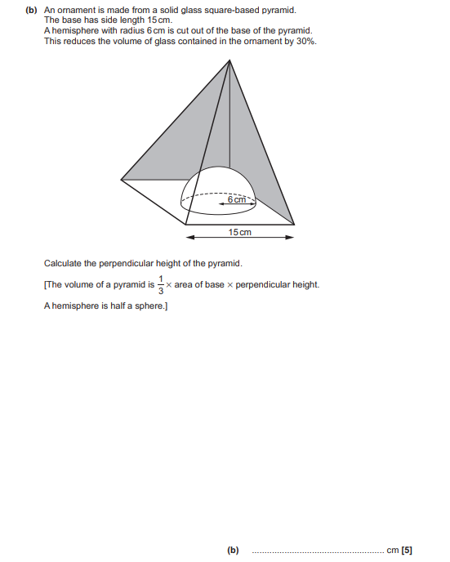

OCR GSCE – Tuesday 6 November 2017 – Paper 5 (Non - Calculator) Higher Tier
97.
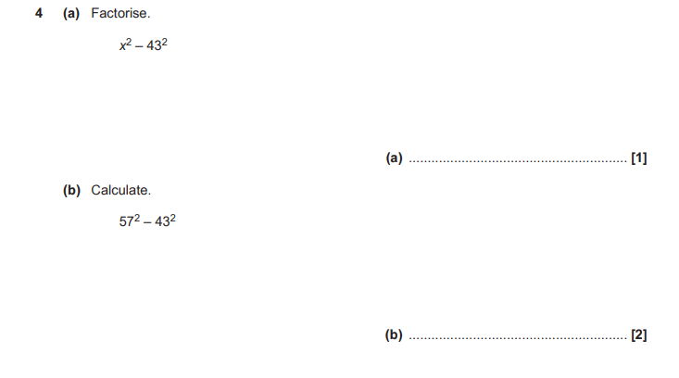
OCR GSCE – Tuesday 13 June 2017 – Paper 6 (Calculator) Higher Tier
98.
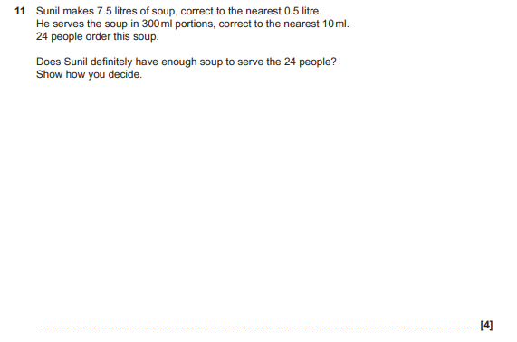
OCR GSCE – Tuesday 13 June 2017 – Paper 6 (Calculator) Higher Tier
99.
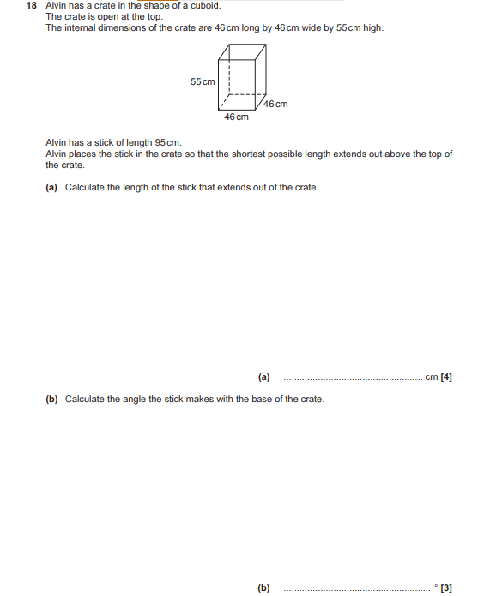

OCR GSCE – Sample Papers – Paper 4 (Calculator) Higher Tier
100.
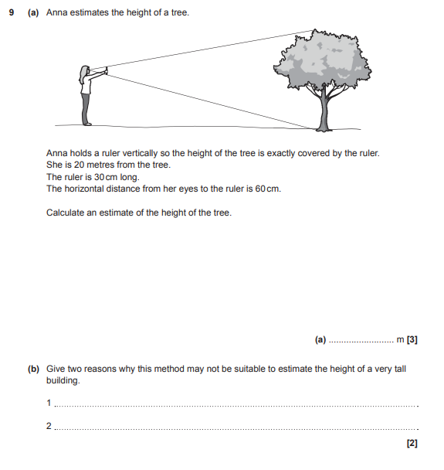

AQA GSCE – Thursday 8 November 2018 – Paper 2 (Calculator) Higher Tier
101.
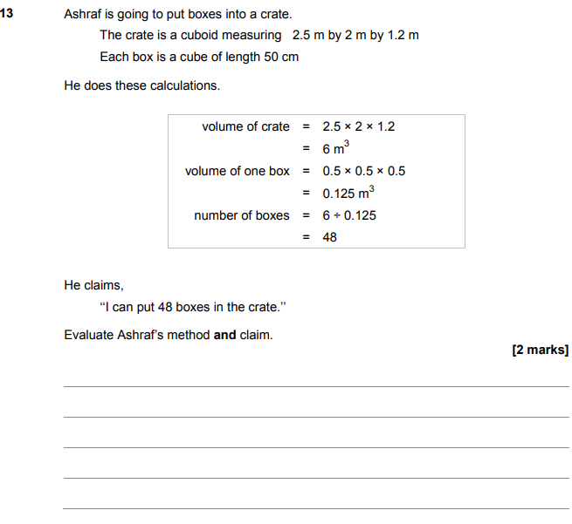

AQA GSCE – Thursday 7 June 2018 – Paper 2 (Calculator) Higher Tier
102.
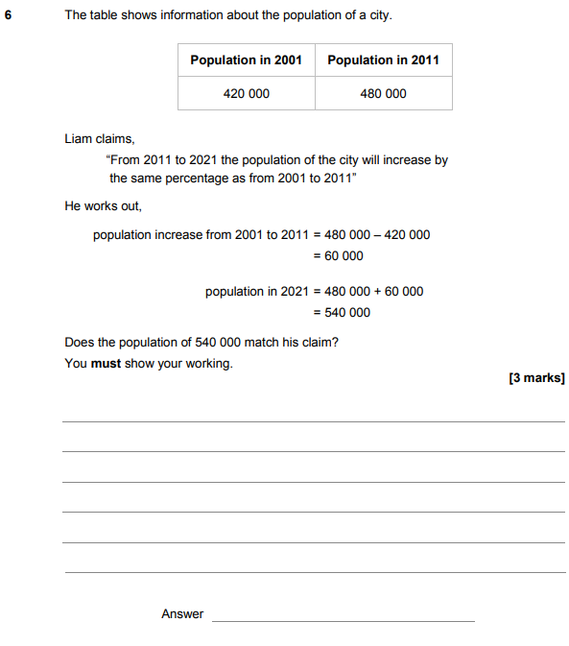

AQA GSCE – Sample Paper 3 (Calculator) Higher Tier
103.
